M6 hand on

Getting crawled folder

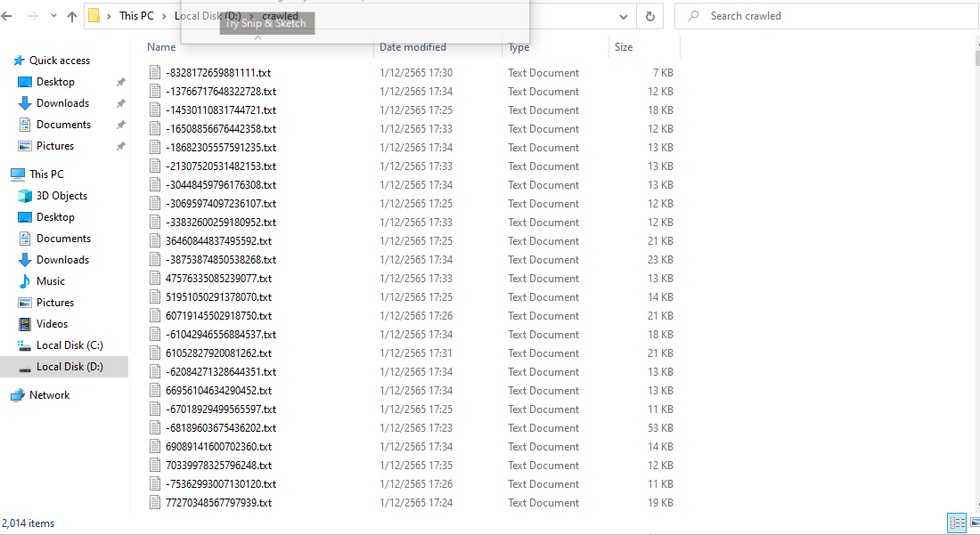

Solr

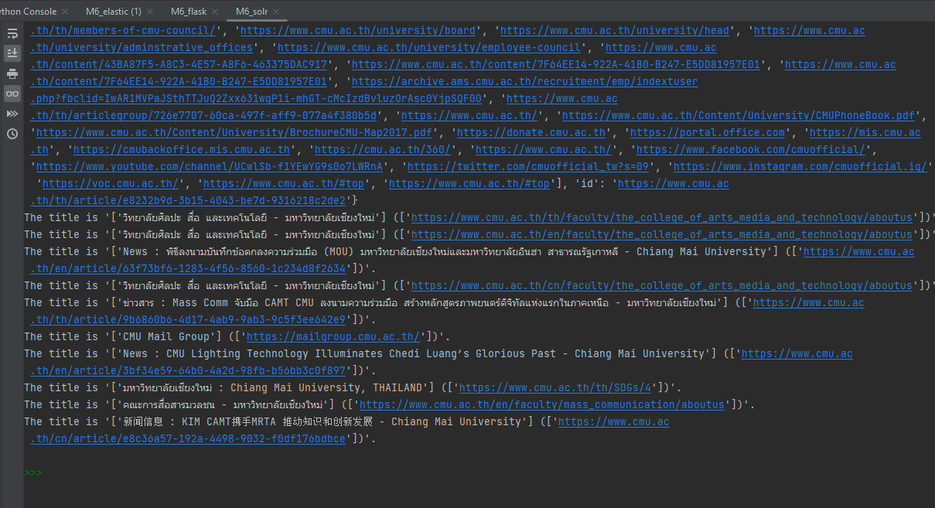

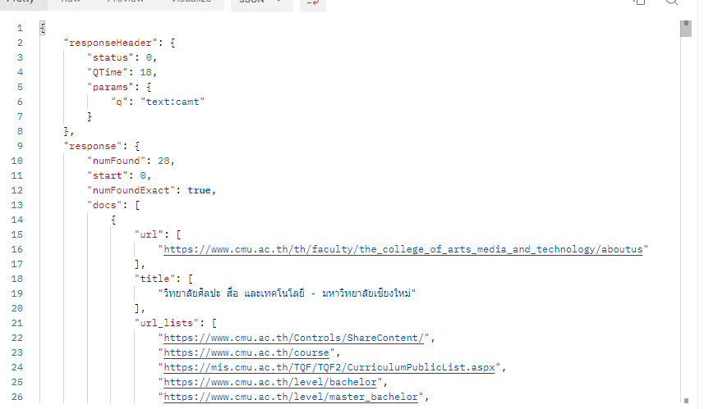

Elastic search

